Appendix I
This appendix is, in the main, copied from Willmott (2009) and Willmott et al (2017).
White Mountains National Park in context of the Great Australian Basin
White Mountain National Park is on the eastern margin of the Great Australian Basin, often called the Great Artesian Basin (Fig A1). The sandstones that are the water-bearing aquifers of the great Australian Basin initially accumulated as sediments from Jurassic river systems. Inland seas then spread from the north in several episodes, depositing sediments in shallow marine environments. During the early Jurassic (205 to 175 my), vast amounts of sediments accumulated across, and filling, the central plains of the Surat basin in the south and southwest. Further sediments accumulated during the mid-Jurassic (174 to 163 my) in the broadened slow-flowing rivers, swamps and lakes.
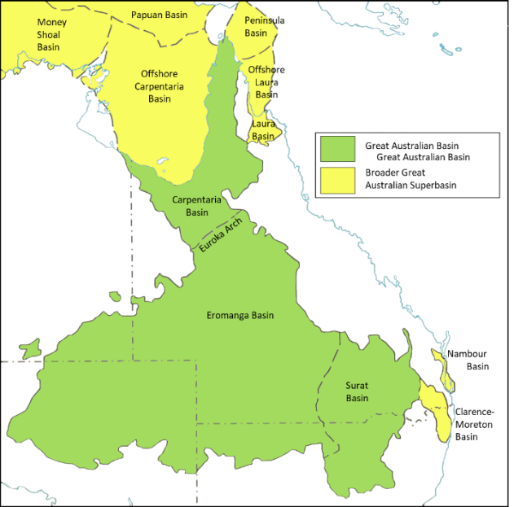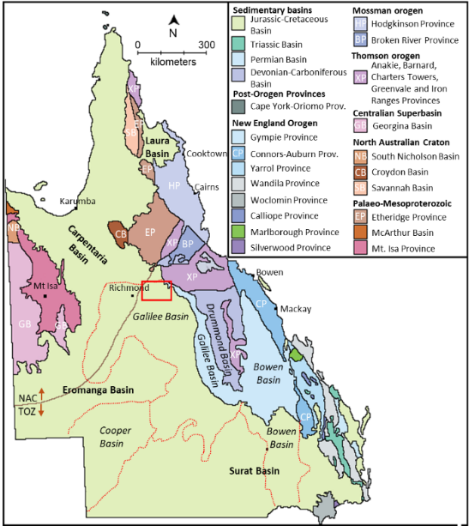
Fig A1. Left: the Great Australian Basin and the Broader Great Australian Superbasin (from Willmott et al 2017). Right: geological provinces in Queensland. The red box encloses Porcupine Gorge and White Mountains National Parks. Red lines are Carboniferous to Triassic basins that lie beneath Jurassic to Cretaceous basins. Basins in bold type overlie Cretaceous-Jurassic basins. Basins in italic type underlie older basins. NAC = North Australian Craton, TOZ = Tasman Orogenic Zone.
During the late-Jurassic (163 to 145 my) sedimentation continued after a brief hiatus. By the end of the Jurassic, the Surat, Eromanga, Carpentaria and associated basins were a united system. The deposition of the non-marine sediments continued to ca 135 my in the early Cretaceous when changes in climate, sea level and movement of continental plates, caused the basin to sink (Fig A2).
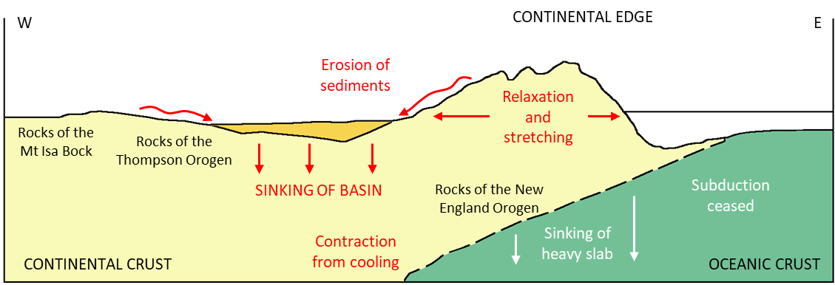
Fig A2. A mechanism for the sinking of the Great Australian Basin, ca 210 my (from Willmott et al 2017).
Sinking of the Basin led to incursions of marine waters and the formation of a shallow inland sea, the Eromanga Sea, which formed and retreated five times between 135 my and 100 my (Fig A3). There is no evidence of ice in the sea as, although Australia was located at high Gondwanan latitudes, it was a period when temperatures were warmer than in modern times. Although generally shallow, and islands were present, water depths reached to ca 150 m in places. Poor bottom-water circulation resulted in widespread anoxia on the sea-floor.
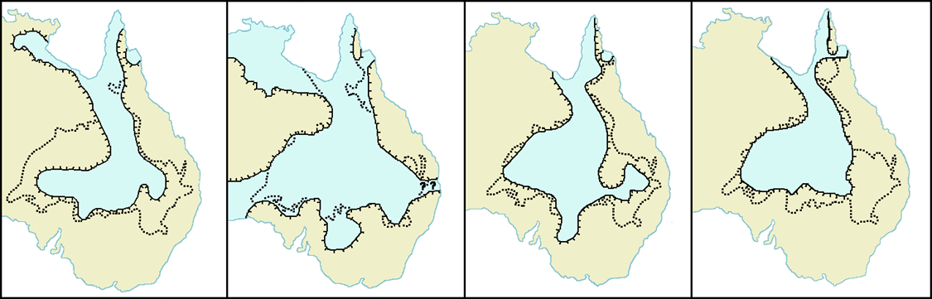
Fig A3. The 2nd to 5th Cretaceous Eromanga inland marine seas. From left, 2nd (125 – 120 my, early Aptian), 3rd (116 to 113 my, late Aptian), 4th (108-105 my, late-early to middle Albian) and the 5th (102-100 my, late Albian). The dots show the position of the Great Australian Basin. From Willmott et al 2017.
Increasing amounts of sediment deposited in the Eromanga Seas is derived from volcanics (Fig A4). The source was perhaps a chain of volcanoes that developed along the eastern edge of the continent (129-105 my). Melting of the lower crust and molten magmas that rose to the surface were probably precursors to the more easterly fracturing that led to the opening of the Coral Sea (ca 50 to 60 my).
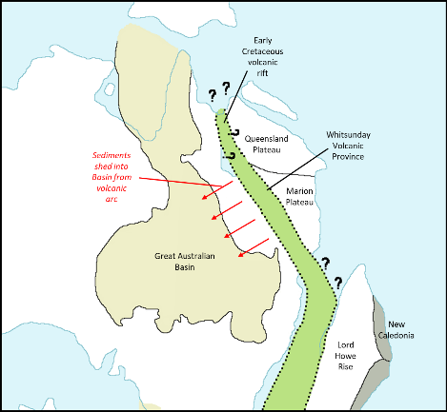

Fig A4. A volcanic rift possibly fractured the eastern side of the Australian continent during the early Cretaceous, providing the fine volcanic sediments that constitute much of the later layers of the Basin.
Dry land returned (100 to 93 my, the Cenomanian) when the last inland sea retreated to the north through the channel between Mt Isa and Georgetown leaving behind freshwater lakes, swamps and flood-plains. Sediments from these landscapes are up to 1,000 m thick in the Winton Formation.
Over time, the weight of the accumulated sediments, up to 3,000 m thick, combined with tectonic uplift on the eastern margins have folded the Basin rocks into an irregular saucer shape. The eastern edge, elevated in one or more episodes, possibly due to upward doming of the eastern part of the continent, prior to the fracturing and opening of the coral sea in the mid-Tertiary (50 to 60 my) raised the early beds of river sandstone to the east. Today, at White Mountains National Park, they act as intake beds for ground-water and provide a head of pressure in the west (Figs A5 and A6).
As Australia broke from Antarctica and drifted northwards conditions became warmer and drier and there has been a long era of weathering and erosion in the interior of the basin until the Paleocene (ca 60 my). Plains developed over SW Queensland accompanied by chemical alteration of the underlying rock. A hardened silica-enriched cap (silcrete) developed over an intermediate red and white mottled layer and leached white bottom layer (Fig A6). Later erosion of the surface and lowering of the landscape, often by hundreds of metres, has resulted in the hard crusts remaining as the tops of plateaus, mesas and ridges. Willmott (Willmott 2009, Willmott et al 2017) notes that such profiles tend to develop in tropical or sub-tropical climates, particularly those with seasonal rainfall, but that Australia was still in high latitudes at the time. A possible precursor to the north Australian process may have been the high oxidising potential of the sediments that were produced under anoxic conditions of the earlier sea-floors.

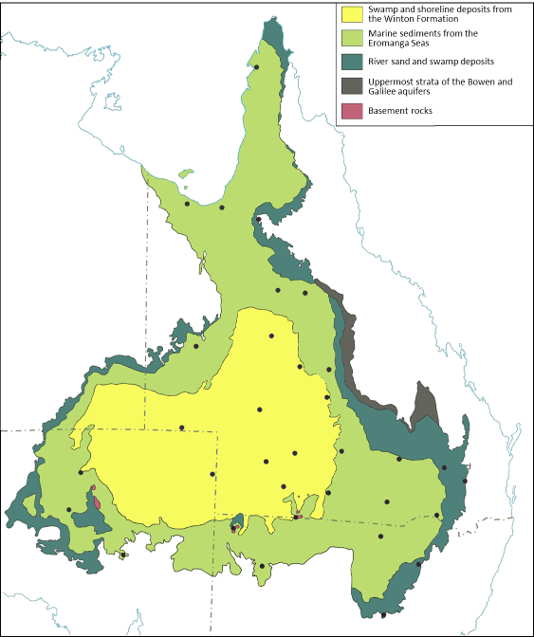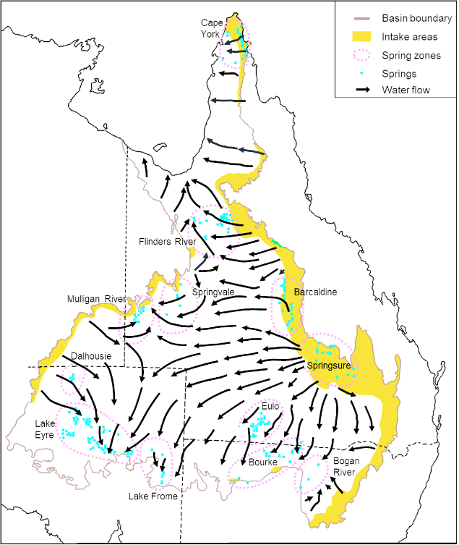
Fig A5. Left: overview of the Jurassic-Cretaceous geology of the Great Australian Basin. The deposits in the margins extend beneath the younger rocks in the centre and form the major aquifers. The basin extends into the Clarence-Moreton and Laura basins on the east and continues offshore beneath the Gulf of Carpentaria. Right: water intake areas for the Great Australian Basin, flow directions of underground water, and locales of springs. White Mountains National Park is on the eastern edge in lime (Figs from Willmott et al 2017, and Habermehl and Lau 1997).
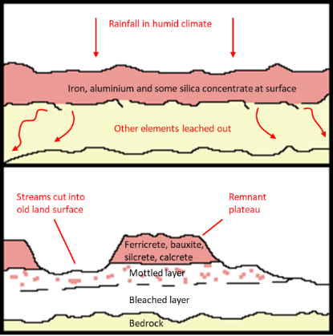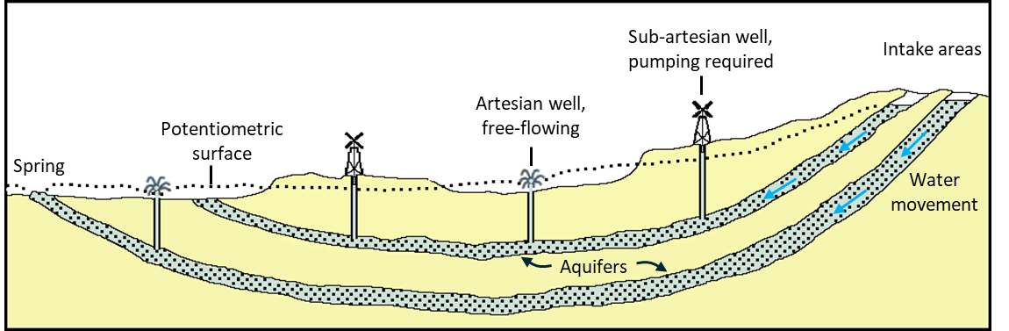
Fig A6. How mesas and plateaus form (top) and how artesian water flows occur (bottom). The head of water depends upon the nature of the aquifers and the amount of water in them (Willmott et al 2017).
Origins of the sandstones and associated rocks in National Parks at Porcupine Gorge, Cobbold Gorge, White Mountains and in Cape York Peninsula
The earliest sandstones in the parks were deposited in the northern end of the Galilee Basin in the Triassic. The Basin subsided from latest Carboniferous through the Permian to the mid-Triassic (300 to 235 my). It lay to the west of mountainous country along the coast and northwest of the related but deeper Bowen Basin to the south. Except along its eastern edge, most of the Galilee Basin rocks are now obscured by younger ones of the Eromanga Basin. By the end of the mid-Triassic (235 my), a covering of quartz sand was deposited on broad river plains around its northern end. These eventually consolidated to the Warang Sandstone, which now outcrops in the White Mountains and in central Porcupine Gorge. The sands were preceded by finer sediments deposited in swampy conditions in the late Permian (Bett’s Creek beds, 260 my), and the Boondaroo beds deposited from glacial rivers in the early Permian (290 my) when the climate was colder. Both of these rock units outcrop in upper Porcupine Gorge.
Younger sands were deposited on river plains over a vast tract of north Queensland, in the broad and shallow subsiding areas of the Eromanga and Carpentaria Basins. These sands covered the entire western margin of the older rocks of the Georgetown Inlier and Cape York Peninsula. The Laura Basin also subsided in the east of the Peninsula, and was at times connected to the Carpentaria Basin. The earliest sediments were sands deposited on broad river plains in low areas around the margins of the basins, in early to late Jurassic times (190 to 150 my). These consolidated to the Blantyre Sandstone near Hughenden, the Hampstead Sandstone west of Forsayth, the Dalrymple Sandstone in the Laura Basin, and the Garraway beds in northern Cape York Peninsula.
After a hiatus, volumes of sand were deposited across the expanse of all the basins from the late Jurassic to early Cretaceous (150 to 120 my), and these consolidated to the Gilbert River Formation. This is present at depth under the entire Carpentaria Basin, at least as far as the west coast of the Peninsula, as well as within the Laura Basin.
Most of the sands were deposited from rivers but during this time the sea began to invade from the north. The youngest beds of the unit were deposited around the margins of the sea, the shoreline, in deltas and in estuaries. In the north, where the sea invaded first, all the sandstones of this age are called the Helby beds and are marginally marine. These underlie the Jardine River National Park and Heathlands Resources Reserve. Once the sea had fully invaded the basins in the early Cretaceous (120 to 100 my), finer marine sediments such as fine sands, silts and muds, and calcareous muds were deposited. During this time the sea advanced and retreated twice. These sediments consolidated to the rocks of the Rolling Down Group in all three basins. Being soft and easily eroded, they outcrop poorly, but they underlie much of the western side of the Peninsula and central part of the Laura Basin. In the south, siltstone of the Wallumbilla Formation, one of the units of the Rolling Downs Group, can be seen on top of sandstone of the Gilbert River Formation in the lower Porcupine Gorge. All in all, there were five marine inundations.
Summary of the sandstones
A common feature of river-deposited sandstone units is ‘cross-bedding’, caused by sand deposited at an angle down the advancing face of a sand bank within a stream channel. Floods deposited thin horizontal layers over the banks, which in turn were covered by the next advancing sand bank.
Galilee Basin rocks
- Warang Sandstone. Thick beds of brilliant white, coarse quartz sandstone deposited from broad rivers, commonly with large-scale cross-bedding. Where eroded by streams forms lines of cliffs, but as it has a soft, kaolinite clay cement, patches of the rock easily fret away to undercut caves and overhangs. In places there are thick beds of conglomerate (consolidated gravels), siltstone and mudstone within the sandstone.
Eromanga-Carpentaria-Laura Basin rocks
- Blantyre Sandstone. Brown, medium to coarse-grained quartz or mica-quartz sandstone forming thick beds, which give convex slopes on cliff sides.
- Hampstead Sandstone. Grey quartz sandstone with prominent cross-bedding and some fossil wood fragments. It has beds of conglomerate at its base, and some beds of fine-grained sandstone and siltstone in places.
- Dalrymple Sandstone. Conglomerate, feldspar-quartz sandstone, siltstone, claystone and coal, in a series of beds becoming repeatedly more fine-grained towards the top, suggesting fluctuating conditions where a river entered the sea. Coal seams in the unit have been explored in the Bathurst Range northeast of Laura.
- Gilbert River Formation. Extremely widespread and hence is variable between regions. In the south, reddish-white mottled, coarse to very fine-grained quartz sandstone, cemented by carbonate, with interbedded claystone and flecks of coal. Cross-bedding is prominent, suggesting deposition by streams. In the Laura Basin and further north, it is more feldspathic, calcareous and clay-rich, with minor calcareous siltstone, claystone and conglomerate, suggesting deposition in tidal estuaries. This reflects the advance of the sea from north to south during the time the unit was being deposited.
- Helby beds. Yellow, fine to medium-grained, soft clayey sandstone with some thinly bedded shale and siltstone. Evidence of churning over of the finer sediments by marine organisms. Outcrops only in cliffs and stream beds.
Landscapes
The quartz sandstones of the various sandstone units within the parks are resistant to erosion, and being in horizontal beds, tend to form flat-topped plateaus or mesas bordered to varying extents by cliff lines. Erosion by creeks has been down prominent fracture planes. Sandstones give poor, commonly deep, sandy soils, which support low eucalypt and heath vegetation but the process of landscape development differs considerably between parks.

